**DAILY ONLINE ACTIVITIES SUMMARY**

|  |  |  |  |  |  |  |  |
| --- | --- | --- | --- | --- | --- | --- | --- |
| **Date:** | 20-06-2020 | | | | **Name:** | Gudugunti Anirudh | |
| **Sem & Sec** | IV - A | | | | **USN:** | 4AL18CS023 | |
| **Online Test Summary** | | | | | | | |
| **Subject** | | Data communication | | | | | |
| **Max. Marks** | | 30 | | **Score** | | 29 | |
| **Certification Course Summary** | | | | | | | |
| **Course** | Introduction to digital marketing | | | | | | |
| **Certificate Provider** | | | Great learning | **Duration** | | | **2.5 hrs** |
| **Coding Challenges** | | | | | | | |
| **Problem Statement:**  1: Program to rotate a square matrix by 90 degree either clockwise or anti-clockwise. | | | | | | | |
| **Status:** Completed | | | | | | | |
| **Uploaded the report in Github** | | | | yes | | | |
| **If yes Repository name** | | | | https://github.com/alvas-education-foundation/anirudh_gudugunti/tree/master/daily_progress | | | |
| **Uploaded the report in slack** | | | | yes | | | |

**Online Test Details:** The online test was on modules 3 and 4 which was all of objective type. The questions are optimal and easy. There were 30 questions for 30 minutes. The score that I got was 29/30.

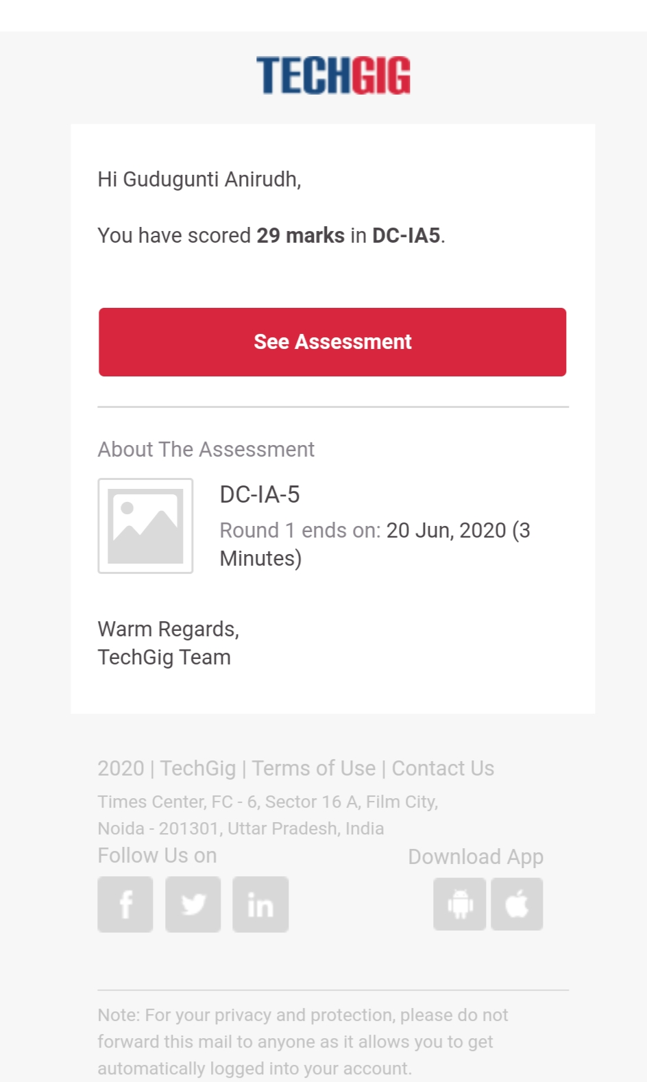

Snapshot of certification course:

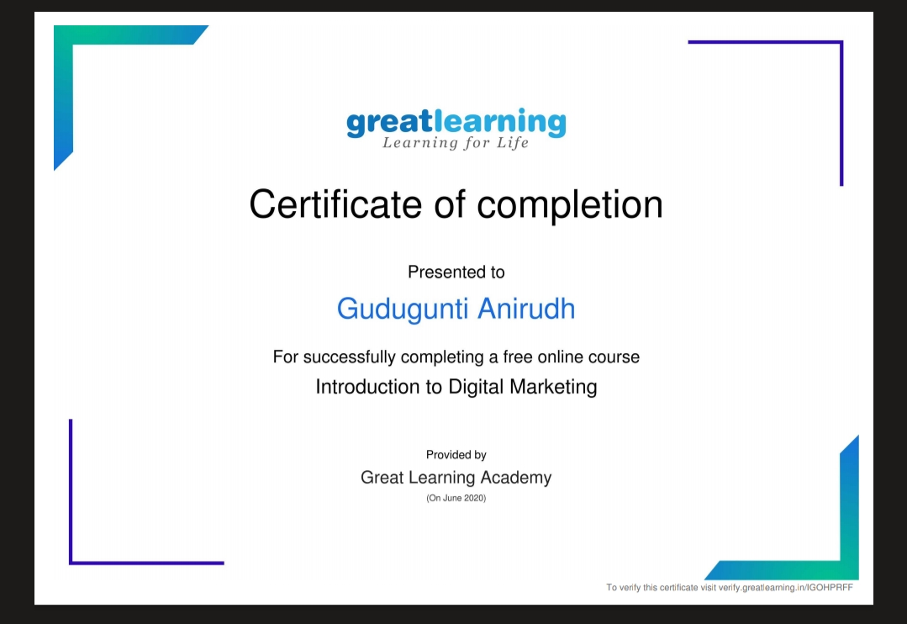

: Today I have completed successfully a free online course i.e; Introduction to digital marketing. I took online quiz and completed the course. They provided a certificate of completion.

**Online coding:**

Problem 1: (using C language) Program to rotate a square matrix by 90 degree either clockwise or anti-clockwise.

